TUOM_4COL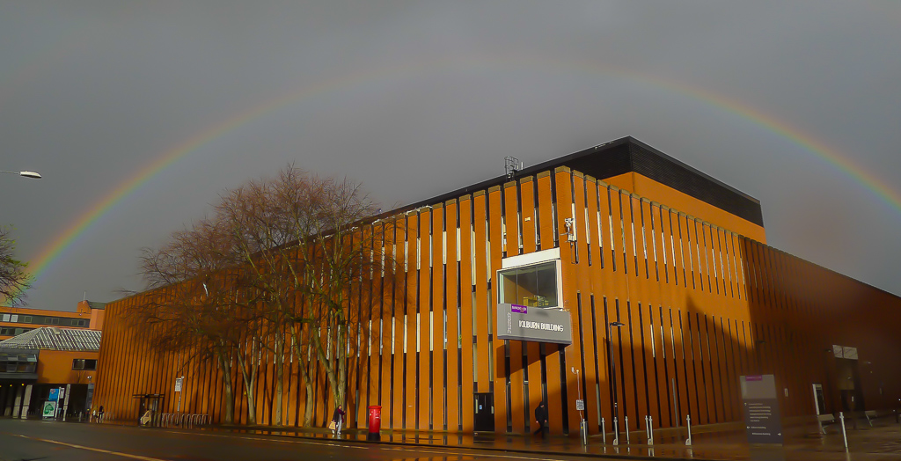

**About us**

At The University of Manchester, we have the longest established school of computer science in the UK and one of the largest. We are constantly building on our strong research history with research groups operating across the spectrum of computer science, from fundamental theory and innovative technology, through novel hardware and software systems design, to leading-edge applications.

The School is consistently ranked highly; 2nd in UK for ‘research power’ (RAE2008); 5th in the UK by ARWU 2013 and the expertise and achievements of our staff are well-recognised internationally.

**In this issue**

p.2 Head of School Editorial and Research News

p.4 Spotlight – The National Centre for Text Mining (NaCTeM)

p.5 Feature – Phantoms of the Mind

p.6 Recent Appointments

p.7 Grants and Awards

**Contact us**

**School of Computer Science**

**The University of Manchester**

**Kilburn Building**

**Manchester**

**M13 9PL**

**UK**

**Email:** [**researchsupportcsm@manchester.ac.uk**](mailto:researchsupportcsm@manchester.ac.uk)

**Web:** [**www.cs.manchester.ac.uk**](http://www.cs.manchester.ac.uk)

The School of Computer Science - Kilburn Building

**Issue 1 – Spring 2014**

**School of Computer Science**

Research

Newsletter

Editorial by the Head of School

### I’m very pleased to introduce the first issue of the School of Computer Science Research Newsletter We have one of the broadest range of research interests of any School of Computer Science in the UK: from nanoscale electronic devices to Exabytes. We collaborate across the globe and with every faculty in the University which is a measure of the diversity and impact of what we do. I’m delighted to be able to share some of our recent research news and discoveries with you.

### Professor Jim Miles

### News

**Congratulations to Professor Steve Furber, who has been announced as a BCS Distinguished Fellow**.

At the 2014 IET/ BCS Turing Lecture hosted at The University of Manchester in February, it was announced that Professor Steve Furber has been awarded as a Distinguished Fellow by BCS, The Chartered Institute for IT. As a Distinguished Fellow, Prof. Furber joins some of the top names in the history of the industry including Bill Gates, Sir Tim Berners Lee, Vint Cerf and Manchester’s first Computer Science Head of School, Prof.Tom Kilburn (1974).

The BCS Distinguished Fellowship is awarded to members of the computing profession who have made an outstanding contribution to the advancement of computing over a substantial and sustained career. This prestigious award is only presented from time to time, with only 27 people having been selected for the title since its inception in 1971.

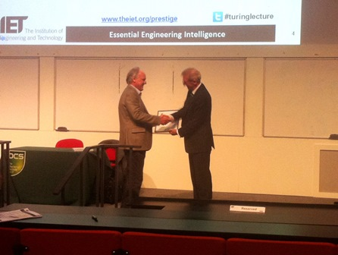Prof. Furber has also been honoured as the recipient of the **BCS Lovelace Medal 2014** for his significant contribution to the advancement of Information Systems. David Clarke MBE, the Institute’s Group Chief Executive Officer says of the awards:  
**'These awards recognise Steve Furber’s outstanding contribution to the IT profession and industry. He is responsible for some of the most innovative work in the field of computing.'**

Upon receiving the awards, Prof. Furber said:  
**‘It is a great honour to receive these awards. I have been very fortunate to work with many outstanding colleagues both at Acorn and at Manchester, and to find myself in the right place at the right time to work on projects that turned out to have an impact. The first half-century of computing has been extraordinarily exciting, but watch out, because the next half-century promises even bigger changes and more rapid development!’**

Read more through the BCS press release <http://www.bcs.org/content/conWebDoc/52206>

Prof. Furber CBE, FRS, FREng has also recently featured:

* in the Science Council’s 100 leading UK practising scientists [www.sciencecouncil.org/content/100-leading-uk-practising-scientists](http://www.sciencecouncil.org/content/100-leading-uk-practising-scientists)
* in Big Issue in the North (10th March edition)
* in Forbes [www.forbes.com/sites/jenniferhicks/2013/12/05/one-million-chips-mimic-one-percent-of-the-brain-a-robots-neural-network/](http://www.forbes.com/sites/jenniferhicks/2013/12/05/one-million-chips-mimic-one-percent-of-the-brain-a-robots-neural-network/)
* at the Museum of Science and Industry (MOSI) within the Wellcome ‘Brains – The Mind as Matter’ exhibition [www.mosi.org.uk/whats-on/brains-the-mind-as-matter.aspx](http://www.mosi.org.uk/whats-on/brains-the-mind-as-matter.aspx)

For more information contact Prof. Steve Furber <http://apt.cs.man.ac.uk/people/sfurber/>

**Professor Uli Sattler - member of Academia Europaea**

Congratulations to Uli Sattler on becoming a member of Academia Europaea! The Academia Europaea is a European Academy of Humanities, Letters and Sciences, where membership is by invitation only. Invitations are made only after peer group nomination, scrutiny and confirmation as to the scholarship and eminence of the individual in their chosen field.

Uli’s research interests are in logics for knowledge representation and automated deduction. More specifically, in Description, Modal, and Dynamic Logics, the corresponding inference problems, their complexity, and decision procedures for these problems.

For more information contact Prof. Uli Sattler [www.cs.man.ac.uk/~sattler/](http://www.cs.man.ac.uk/~sattler/)

# Launch of European Big Data project RETHINK big Researchers from Computer Science helping to create a Big Data roadmap for Europe.

The RETHINK big project was launched in March. The project brings together key European hardware, networking, and system architects with the key producers and consumers of Big Data to identify the industry coordination points. Specifically, RETHINK big will deliver a strategic roadmap for how technology advancements in hardware and networking can be exploited for the purpose of data analytics and beyond. The overall aim of the project is to maximize European competitiveness in the processing and analysis of Big Data over the next 10 years.

Within the School of Computer Science at The University of Manchester, Big Data is a key research area. Researchers involved in the project include **Dr Mikel Lujan**, **Dr Gavin Brown**, **Dr Josh Knowles**, **Dr Jim Garside**, **Dr Vasilis Pavlidis**, **Dr Dave Lester**, **Dr Javier Navaridas**, **Dr Nick Filer**, **Prof. Robert Stevens**, **Prof. Carole Goble** and **Prof. Tom Thomson**, with input from many more individuals across the University within our Big Data community.

**Manchester Big Data Events:**

• **May 2014: Big Data Sandpit 'What would a Research Centre in Big Data look like?’**

Exploring potential models for establishing a Big Data Research Centre at Manchester (internal event)

• **July 2014: 'Showcasing Manchester's strengths in Big Data'**Our two-day July event will be the largest in the series: industry and organisations working in Big Data are invited to attend, with a view to exploring potential collaborations.

For more information see: [www.informatics.manchester.ac.uk/Research/digitaleconomyandsociety/Pages/BigData.aspx](http://www.informatics.manchester.ac.uk/Research/digitaleconomyandsociety/Pages/BigData.aspx)

**First ACM-W Europe WomENcourage Conference**

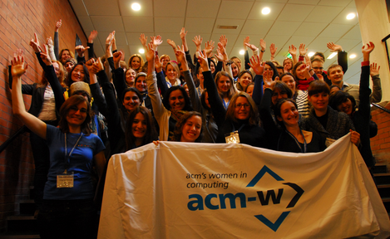This inaugural event on Saturday 1st March 2014 was hosted in the School and brought together 240 computing academics, students, researchers and practitioners from over 30 countries. The event, chaired by Manchester’s **Dr Eva Navarro-Lopez**, featured inspiring talks from Prof. Dame Wendy Hall (Southampton), **Prof. Carole Goble** (Manchester) and Dr Yasemin Altun (Google), lively panel sessions considering the future of computing, and an 'unconference' session where breakout groups addressed questions ranging from politics to cyber security.

Generous supporters of ACM-W womENcourage 2014 include Google, Bloomberg, Intel, Microsoft Research, Facebook, Yahoo Labs and Cisco, all of whom were represented at the event.

Eva was interviewed by Andy Crane on BBC Radio Manchester to promote the event for **‘some of today’s brightest and best female computer scientists’** to ensure that **‘more women (are) encouraged into the industry’**.

[www.cs.manchester.ac.uk/about-us/news-and-events/past-events/acm-womencourage-europe/](http://www.cs.manchester.ac.uk/about-us/news-and-events/past-events/acm-womencourage-europe/)

### Sean Bechhofer - author of the most cited paper in 2013! Congratulations to Sean Bechhofer and Matthew Horridge for their paper: The OWL API: A Java API for OWL ontologies being the **most cited paper** currently in the Semantic Web Journal – 99 citations in 2013!

<https://twitter.com/sw_journal/status/437080186769903616>

### Manchester computer science – appealing to all ages!

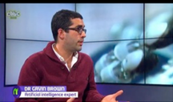**Professor Steve Furber** and **Dr Gavin Brown** featured on CBBC’s Newsround in March, talking about modelling the human brain and the future of AI.As part of their Robot Series, CBBC Newsround interviewed Steve and Gavin about their research and implications for robots and computers of the future.

You can view the interviews through [www.youtube.com/watch?v=WrZmR3bRgkU](http://www.youtube.com/watch?v=WrZmR3bRgkU)

Spotlight: The National Centre for Text Mining [(NaCTeM)](http://www.nactem.ac.uk)

The National Centre for Text Mining (NaCTeM) at The University of Manchester was established in 2004 and is the first publicly-funded text mining centre in the world, developing text analytics tools and search services for UK academia and industrial partners. The Text Mining group is led by **Professor Sophia Ananiadou** and **John McNaught**.

Text mining software facilitates the discovery, extraction and structuring of relevant knowledge from unstructured text. This involves three main activities:

* Information retrieval to gather relevant facts
* Information extraction to identify and extract entities, facts and relationships between them
* Data mining to find associations among the pieces of information extracted from many different texts

Text mining facilitates the identification, management and exploitation of information from across a large collection of documents that would be unfeasible with traditional search methods. This process helps to make implicit information in documents more explicit, saving time and effort. It can be used to discover previously unknown information. The information might be relationships or patterns that are buried in the document collection and which would otherwise be extremely difficult, if not impossible, to discover.  
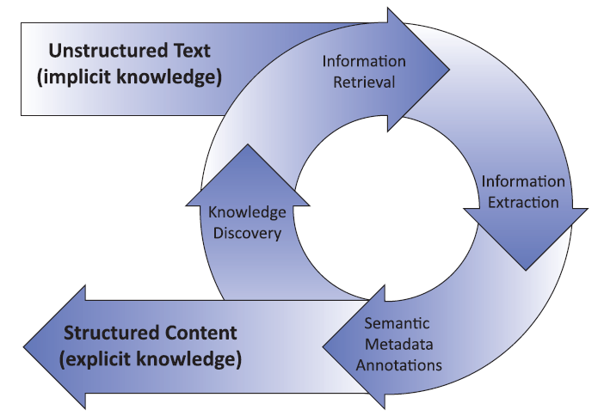For example, an important area of research for the development of drugs is the interactions between proteins and how these can be modified if they are linked to disease. Text mining can not only extract information on protein interactions from documents, but also goes a step further to discover patterns in the extracted interactions. Information may be discovered that would have been extremely difficult to find, even if it had been possible to read all the documents. This information could help to answer existing research questions or suggest new avenues to explore.

Other application areas for text mining include: chemistry, systems biology, clinical trials, public health, medical historical archives records, newswire analysis, social media and publishing. Text mining relies upon the application of research techniques from areas such as information retrieval, natural language processing, information extraction and data mining.

In 2013, NaCTeM’s text mining tools were ranked highest in three separate tasks at BioCreative IV, in which teams from academia and industry apply their technology to extract biological information from text. NaCTeM's systems outperformed other participating systems in the following tasks (tracks):   
• the Comparative Toxicogenomics Database (CTD) track - recognising 4 concept types: chemicals, genes, diseases and action terms. Out of 12 participating teams, the NaCTeM team:  
i) achieved the best results for the recognition of chemicals and genes (out of 12 teams);  
ii) ranked highest in terms of combined performance of the recognition of all 4 concept types  
• the Chemical and Drug Named Entity Recognition (CHEMDNER) track - the Chemical Document Indexing (CDI) subtask: NaCTeM was ranked 1st out of the 23 teams participating.

NaCTeM ([www.nactem.ac.uk/](http://www.nactem.ac.uk/)) is funded by JISC, BBSRC, MRC, AHRC, Wellcome Trust, NIH and industrial partners.

Feature: Phantoms of the Mind

**Dr Steve Pettifer**

Photo by Solarshine



As part of the School seminar series, **Dr Steve Pettifer** presented his work on **Phantom Limb pain** (PLP). PLP is the chronic experience of pain in the residual impression of a limb that persists following amputation, and is one of the most distressing consequences of amputation. The problem of PLP is large and pervasive in the lives of many amputees with about 60–80% of amputees developing pain in their missing limb. Even people who are born without a limb can suffer from PLP. Consequently, there are millions of people in the world that are affected by pain from a limb that does not exist.

**The research at Manchester explores virtual reality techniques for assisting the rehabilitation of amputees.** These people suffer debilitating chronic phantom limb pain and have so far responded poorly to the current range of pharmaceutical, surgical, and psychological treatments.

Visual therapies for amputees, such as virtual reality provides a possible alternative and non-invasive treatment for amputees, where in some cases the pain is alleviated when amputees can ‘see’ and ‘move’ their

phantom limb. A key development was Ramachandran’s mirror box experiment, which allows amputees to view a reflection of their existing limb in the visual space occupied by their phantom limb. Ramachandran reported evidence that the mirror box induced vivid sensations of movements originating from patients’ phantom limbs, and in some cases relieved their PLP.

In 2006, Steve’s group in Manchester built an Immersive Virtual Reality (IVR) system in partnership with pain medicine consultant Prof. Ilan Lieberman. This system provided an immersive stereoscopic visual representation of the amputee’s whole body. It used electromagnetic tracking hardware to transpose the movements made by the intact anatomical limb into movements of a computer graphical 'virtual limb' in the phenomenal space occupied by the phantom limb. Activities are used within the virtual environment to encourage the user to move their existing limb, which also causes the movement of their virtual phantom limb. This results in perceived control or ’agency’ over the phantom limb.

Trials have shown that four out of five people experienced reduction in their pain levels and one found that he was even able to exercise some control over the stump of his amputated limb, which had previously been paralysed for over twelve years. The group is currently investigating the advances in the technology to facilitate controlled experiments that will investigate the numerous variables involved in the therapy. Smaller and cheaper off-the-shelf hardware systems are available, meaning that the next generation of IVR are less fragile and can be made more readily available.

Research areas that are key to the success of the work include factors that affect the user’s ‘presence’ with the system. This can be affected by factors such as the tracking fidelity of the existing limb and latency. So, even when there is an imperceptible lag in the virtual environment, the user can be aware that something is not quite right; causing a break in presence and making the experience less compelling.

Another factor that is being investigated is how to best provide plausible and realistic virtual environments. Greatly improved quality graphics are now available. However, there is a balance to be struck between creating a believable virtual limb and ensuring that it is not so close to being realistic that it’s considered creepy! This effect is known as the ‘uncanny valley’ and particularly affects features that are very familiar, such as faces and importantly, hands.

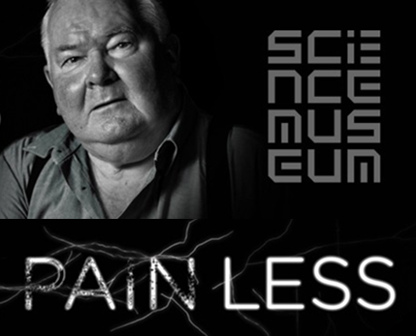Over the last year, the research has been showcased in **the Pain Less exhibition at the Wellcome Antenna gallery in the National Science Museum**. The exhibition features Peter, who has been using the IVR system and reports that on a scale of 1-10 his pain decreases from 8 to 2.

***‘(this has) given me hope that at some point I’ll be able to have a pain-free life’***

Recently, Steve’s group has rebuilt the IVR system using cheap off-the-shelf components including the Occulus Rift head mounted display and the Microsoft Kinect motion tracker, bringing the cost of an installation under £1000 and making the use of the system as an at-home therapy financially plausible. The next step for the research would be to investigate the effects across more people in a clinical-type trial and to understand how long any decreases in pain may last.

Manchester’s phantom limb pain research has featured:

• On the BBC <http://news.bbc.co.uk/1/hi/health/6146136.stm>

• at the Pain Less exhibition at the Wellcome Antenna gallery in the National Science Museum <http://painlessexhibition.wordpress.com/start-here/virtually-painless/>

• at the Manchester museum

For more information contact Dr Steve Pettifer <http://aig.cs.man.ac.uk/people/srp/>

The School research seminar series returns in October. Our seminars are free and available for anyone to attend. For more information see [www.cs.manchester.ac.uk/our-research/seminars/](http://www.cs.manchester.ac.uk/our-research/seminars/)

The School research seminar series returns in October. Our seminars are free and available for anyone to attend. For more information see [www.cs.manchester.ac.uk/our-research/seminars/](http://www.cs.manchester.ac.uk/our-research/seminars/)

Recent appointments

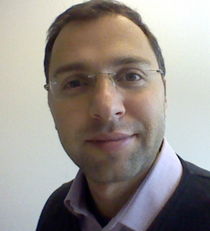

processor architectures. These methods primarily target both off-chip and on-chip communication among the processor chips as well as innovative system integration approaches for improved performance. In addition, he is interested in exploring the potential of emerging technologies and nanoscale devices and assessing the benefits that these fundamental technological advancements can offer into the future processor architectures. Vasilis has active collaborations with ARM and in the past has had also research projects with Intel Research Labs in Germany. He maintains collaborations with highly-esteemed European research centers, such as CEA-LETI. He has co-authored a book on “Three-Dimensional Integrated Circuit Design” which was recently translated into Chinese. Finally, a notable past achievement, which gathered a high interest was the design of the “Rochester Cube”, a small test 3-D circuit that demonstrated few years ago the potential of vertical integration as an emerging technology for integrated systems. <http://www.cs.man.ac.uk/~pavlidiv/index.html>

**Dr Vasilis Pavlidis** is a Lecturer within the Advanced Processor Technologies (APT) group. His core expertise is in the areas of on-chip interconnect analysis, 3-D integration, physical design issues for on-chip networks, and other design issues in VLSI. Vasilis’ role within APT is to develop new design methodologies and techniques that reinforce the performance of the envisaged

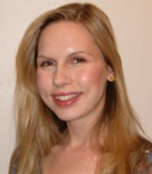

future media, healthcare, knowledge representation and the web. She has collaborated with a number of industry and third sector partners, including Google, Dolby, Age Concern, National Museums Liverpool and Manchester Art Gallery. She is currently working with the BBC on the development of implicit provision user interfaces (IUIs) for media. Prior to taking up the post of lecturer, Caroline completed postdocs in the fields of virtual environments and accessibility, and worked as a software engineer at ALSTOM Power Conversion. She is a member of the Information Management research group. <http://www.cs.man.ac.uk/~jayc/>

**Dr Caroline Jay's** research focuses on modelling human behaviour with technology, and using the results to drive novel interaction techniques. Her work is applied across a number of domains, including television and



much lower power consumption than conventional processors while simultaneously providing more flexibility and programmability in future reconfigurable computing systems. He is currently working on database acceleration using FPGAs where the goal is to build long processing pipelines that are able to perform hundreds of operations simultaneously at several gigabytes per second throughput. Before Dirk started his research on reconfigurable and parallel systems, he worked on power electronics and control systems at the University of Paderborn, Germany. There he also worked on neural networks for classification and function approximation on coarse-grained CPU arrays. During his PhD at the University of Erlangen-Nuremberg, Germany, he developed novel techniques for self-adaptive distributed embedded control systems based on FPGAs. After this, he led a project at the University of Oslo, Norway focusing on making partial reconfiguration of FPGAs more accessible. <http://www.cs.man.ac.uk/~kochd/>

**Dr Dirk Koch** is a new lecturer in the APT group.  His research interest includes reconfigurable computing, high-performance stream processing and tools for implementing run-time reconfigurable systems on Field Programmable Gate Arrays (FPGAs). His work is driven by the demand for providing more processing performance at

# 

# parallel programming abstractions, compiler code generation and optimisation, and dynamic optimisation. He received an MSc from Ecole Nationale Superieure d'Informatique et Mathematiques Appliquees de Grenoble in 2004 and his PhD from MINES ParisTech (formerly Ecole des Mines de Paris) in 2011. Antoniu is the lead designer of the OpenStream programming language ([http://openstream.info](https://outlook.manchester.ac.uk/owa/sarah.chatwin@manchester.ac.uk/redir.aspx?C=qMYhKvM7kU-yZzGQgX87l3AQ_vFXINEI7W_FbU5sV9v00CIgn4kmZs8fWNVE1rp8DCnvNIrliJY.&URL=http%3a%2f%2fopenstream.info)) and a developer of the GCC compiler affiliated to the Free Software Foundation Europe. He has joined the Advanced Processor Technologies group

# [Antoniu.pop@manchester.ac.uk](mailto:Antoniu.pop@manchester.ac.uk)

**Dr Antoniu Pop** was appointed as Lecturer in the School of Computer Science in October 2013. His research interests focus on solving the challenges of the many-core revolution and include high-level

 Zurich in 2007, where he developed a deadlock-avoidance scheme for the interconnection network of a novel large-scale computing system and his pre-doctoral visit to the APT group at The University of Manchester where he studied and modelled the custom-made massively parallel SpiNNaker system. He has also carried out collaborative research with a significant number of other institutions. Javier has led the development of INSEE, a lightweight simulation environment able to cope with very large-scale networks (systems with up to 1M nodes have been modelled). His research interests include interconnection networks for large-scale high performance computing systems and datacentres, networks-on-chip for many-core systems, modelling and simulation of large compute systems and acceleration of Big Data analyses. All of these topics are of vital importance to assist the scalability of future computing systems. <http://personalpages.manchester.ac.uk/staff/javier.navaridas/>

**Dr Javier Navaridas** previously held a prestigious Royal Society Newton Fellowship (7% success rate) at Manchester. Javier obtained his PhD in November 2009 from the University of the Basque Country where he held a 4-year PhD scholarship and a 1-year postdoctoral fellowship. His PhD thesis was awarded an ‘Extraordinary Doctorate Award’ (awarded to the top 5% theses in the 2009/2010 academic year). The core of his publication record (10 journal papers and 17 international conference papers) demonstrates his expertise on interconnection networks where he has made research contributions to their theory and evaluation methodology. These skills were very valuable during his internship with IBM Research

**Dr Dirk Koch** is a new lecturer in the APT group.  His research interest includes reconfigurable computing, high-performance stream processing and tools for implementing run-time reconfigurable systems on Field Programmable Gate Arrays (FPGAs). His work is driven by the demand for providing more and more processing performance at much lower power consumption than conventional processors while simultaneously providing more flexibility and programmability in future reconfigurable computing systems. He is currently working on database acceleration using FPGAs where the goal is to build long processing pipelines that are able to perform hundreds of operations simultaneously at several gigabytes per second throughput. Before Dirk started his research on reconfigurable and parallel systems, he worked on power electronics and control systems during his Masters at the University of Paderborn, Germany. There he also worked on neural networks for classification and function approximation on coarse-grained CPU arrays. During his PhD at the University of Erlangen-Nuremberg, Germany, he developed novel techniques for self-adaptive distributed embedded control systems based on FPGAs. After this, he led a project at the University of Oslo, Norway which was targeting to make partial reconfiguration of FPGAs more accessible.

Grants and awards

# The School of Computer Science has been awarded over £12 million external funding for research over the last two years. Much of the research involves working in collaboration with others across the University and all over the world. Here are just some examples of recent research funding awarded in the School.

# Mining the History of Medicine Manchester Computer Science academics are collaborating with the Centre for the History of Science, Technology and Medicine (CHSTM) to demonstrate the potential of text mining in medical history.

**Prof. Sophia Ananiadou**, John McNaught  
Funding body: AHRC, Big Data Call  
Award amount: £259k

This 15 month project, is a cross-disciplinary collaboration between the National Centre for Text Mining ([NaCTeM](http://www.nactem.ac.uk/)) and the Centre for the History of Science, Technology and Medicine (CHSTM) at The University of Manchester. It seeks to demonstrate the potential of text mining in medical history. To do this, firstly an asset will be created out of two very large, long-running digital sources, the British Medical Journal (BMJ) (1840 - present) and the London-area Medical Officer of Health (MOH) reports (1848-1972), by applying text mining techniques to enrich these data with semantic annotations.  
An important aspect of this work is to build tools to identify and record terminological variation and semantic shift over time, via construction of a temporal terminological inventory from the archives. Then, a semantic search system will be developed to help historians in broadening and deepening their work to ask 'big' questions that cover long periods, without losing sensitivity to changes in terminology and meaning.  
The resulting asset and tools will be used and evaluated in two case studies, exploring the modern epidemiological transition and the creation of a medical surveillance culture, two massively important and interrelated changes in British health experience, where many questions remain unanswered. The methods and results of the case studies will serve as concrete examples of how such an asset and tools can be used.  
The project plans to extend its impact to the following sectors: public health, public policy, publishing, media and libraries, with a view to ensuring sustainability and wider uptake of methods and technologies.  
[www.nactem.ac.uk](http://www.nactem.ac.uk)

**Systems Biology to Identify Molecular Targets for Vascular Disease Treatment**

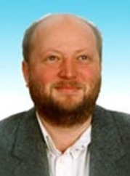**European funding has been awarded to Manchester academics in a project to identify biological mechanisms and key molecules responsible for onset and progression of cardiovascular disease.**

**Prof. Robert Stevens**, Prof. Andy Brass (an EC collaborative project)  
Funding body: EC  
Award amount: €279k

The aim of the SysVasc project is the identification of key factors in the progression of macrovascular disease. SysVasc will develop an ambitious systems medicine approach to uncover molecular pathways involved in the progression of macrovascular disease from early stages to clinical events. Manchester’s role in this multi-site, FP7 funded project is to create knowledge management infra-structure that will allow these analyses to take place over the data generated by other partners; Manchester will also undertake some of those analyses.  
Contact Prof. Robert Stevens for more information [www.cs.man.ac.uk/~stevensr](http://www.cs.man.ac.uk/~stevensr)

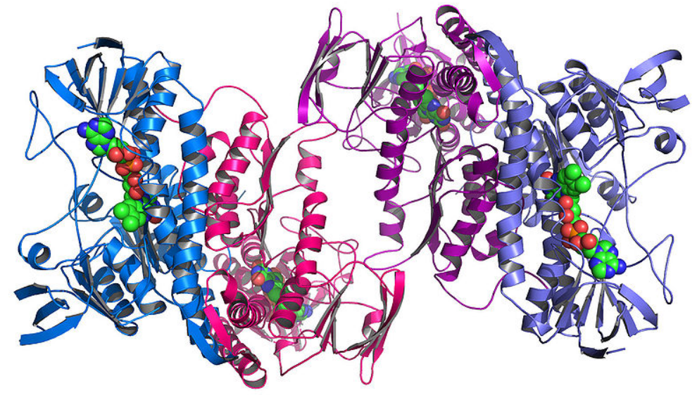**Visualising and optimising very large scale protein sequence-activity data**

**Researchers across the University are working together to develop better tools for visualising proteins.**

**Dr Steve Pettifer**, Prof. Terri Attwood (CS/FLS) and Prof. Doug Kell (Chemistry)  
Funding body: UMRI (The University of Manchester Research Institute) Pump Priming Programme  
Award amount: £33k

Synthetic biology has the potential to radically reduce the cost/ difficulty of creating the proteins that form the active ingredient of around a fifth of all medicines, however new tools are required to visualise/manage the data involved. This project begins the process of adapting our existing protein analysis tools (see <http://utopia.cs.man.ac.uk/utopia/>) for use in the domain of synthetic biology.

**Supporting evidence-based public health interventions**

**This project addresses current limitations in Evidence-Based Public Health (EBPH) interventions by exploring new research methods that combine text mining and machine learning to produce novel search while screening tools for public health.**

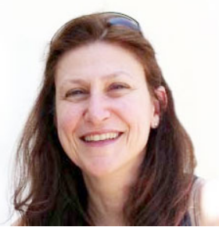**Prof. Sophia Ananiadou**, John McNaught (in collaboration with NICE and the University of Liverpool)  
Funding body: MRC  
Award amount: £637k

The National Centre for Text Mining ([NaCTeM](http://www.nactem.ac.uk/)) at Manchester will investigate novel approaches to EBPH reviewing based on text mining-based unsupervised methods for the discovery of direct and indirect associations to support a dynamic and multi-dimensional relevance required for public health reviews.  In particular, it will build on distributional semantics methods to improve term and document similarity measures by including contextual information in a novel way. Novel descriptive clustering algorithms will be developed that will use these measures to group documents, to analyse their topics to yield meaningful cluster labels and to simultaneously yield high quality document and label clusters. The project will also produce new ranking algorithms to order and visualise meaningful associations in an interactive manner, suitable for EBPH reviewing. This is a collaborative project with NICE and the University of Liverpool.

[www.nactem.ac.uk](http://www.nactem.ac.uk)

**